A Generative AI-Based Avatar Framework Interactive Multilingual Education

line 1: 1st Given Name Surname
line 2: dept. name of organization
(of Affiliation)
line 3: name of organization
(of Affiliation)
line 4: City, Country
line 5: email address or ORCID
line 1: 2nd Given Name Surname
line 2: dept. name of organization
(of Affiliation)
line 3: name of organization
(of Affiliation)
line 4: City, Country
line 5: email address or ORCID
line 1: 3rd Given Name Surname
line 2: dept. name of organization
(of Affiliation)
line 3: name of organization
(of Affiliation)
line 4: City, Country
line 5: email address or ORCID

Abstract—The rapid growth of digital educational content has created a demand for intelligent learning systems that are interactive, adaptive, and accessible across multiple modalities. In developing nations such as India, where the student-to-teacher ratio in higher education exceeds 30:1 and rural regions face acute shortages of qualified instructors, scalable AI-driven tutoring solutions have become increasingly critical [26]. This paper presents AvatarGuru.ai, a Generative AI–based educational framework that integrates with a multimodal avatar-driven learning interface Retrieval-Augmented Generation (RAG). The proposed system enables learners to interact with the content through lip-synchronized instructional animation with text-based and voice-based question answering, AI-generated explanations and assessments.
AvatarGuru.ai enhances engagement and learning effectiveness, the framework renders a 3D avatar generated in Blender and synchronizes its lip movements with synthesized speech using real-time audio amplitude analysis, creating a human-like tutoring experience. It also employs a semantic retrieval pipeline using vector embeddings stored in a vector database to ensure context-aware and document-grounded responses. A large language model is used for explanation generation, question answering, assessment creation, and evaluation, while text-to-speech and speech-to-text modules enable auditory interaction.
The system is implemented using a modular REST-based architecture with scalable backend services and a responsive frontend interface. Experimental deployment demonstrates that AvatarGuru.ai effectively improves content accessibility, learner engagement, and conceptual understanding compared to traditional text-only learning platforms. AvatarGuru.ai is applicable across a range of real-world educational scenarios, including self-paced university course revision, rural K–12 supplementary tutoring, corporate onboarding training, language learning for multilingual learners, and accessibility support for differently-abled students who benefit from multimodal content delivery. For intelligent education systems of the next generation, the proposed framework highlights the potential of combining Generative Avatars, and Multimodal interaction and RAG.
Keywords—AI-based Educational Avatar, Multimodal Learning, Intelligent Tutoring Systems, Semantic Search, Text-to-Speech, Speech-to-Text, Real-Time Lip Synchronization, 3D Avatar Animation, Interactive Education, Retrieval-Augmented Generation (RAG), Generative AI

INTRODUCTION
Unstructured learning resources like PDF files, lecture notes, and digital textbooks have skyrocketed as a result of education’s rapid digitization. While these resources are widely accessible, learners often struggle to efficiently extract relevant information, maintain engagement, and receive personalized guidance. Traditional e-learning platforms largely rely on static content delivery mechanisms, which lack interactivity, adaptiveness, and multimodal support.

India’s education system faces a deep and multi-tiered teacher availability crisis that makes this challenge particularly acute. At the school level, the national Pupil Teacher Ratio (PTR) stands at approximately 26:1 at the primary level, with several states exceeding 30:1, severely limiting the scope for personalized instruction [27]. As of 2021-22, approximately 1.17 lakh single-teacher schools operate across the country, of which 89% are concentrated in rural areas, with states such as Arunachal Pradesh, Telangana, Andhra Pradesh, and Madhya Pradesh among those with the highest proportions [27]. At the national level, over 11.16 lakh teaching positions in schools remain vacant, with 69% of all teaching positions located in rural areas where qualified instructor availability is most constrained [27]. The government reported a shortage of 7,22,413 teachers at the elementary level and 1,24,262 at the secondary level as recently as December 2023 [27]. At the higher education level, the All-India Survey on Higher Education (AISHE) 2021-22 records a national PTR of 24 across universities and colleges in regular mode, with educationally stressed states such as Bihar recording PTRs as high as 74, and Bihar’s PTR has remained among the highest in the country consistently over the past five years [26]. With over 4.33 crore students enrolled in higher education and 25.57 crore in schools, served by a constrained and geographically uneven teaching workforce, the demand for scalable, AI-driven educational solutions has never been more pressing [26], [27].

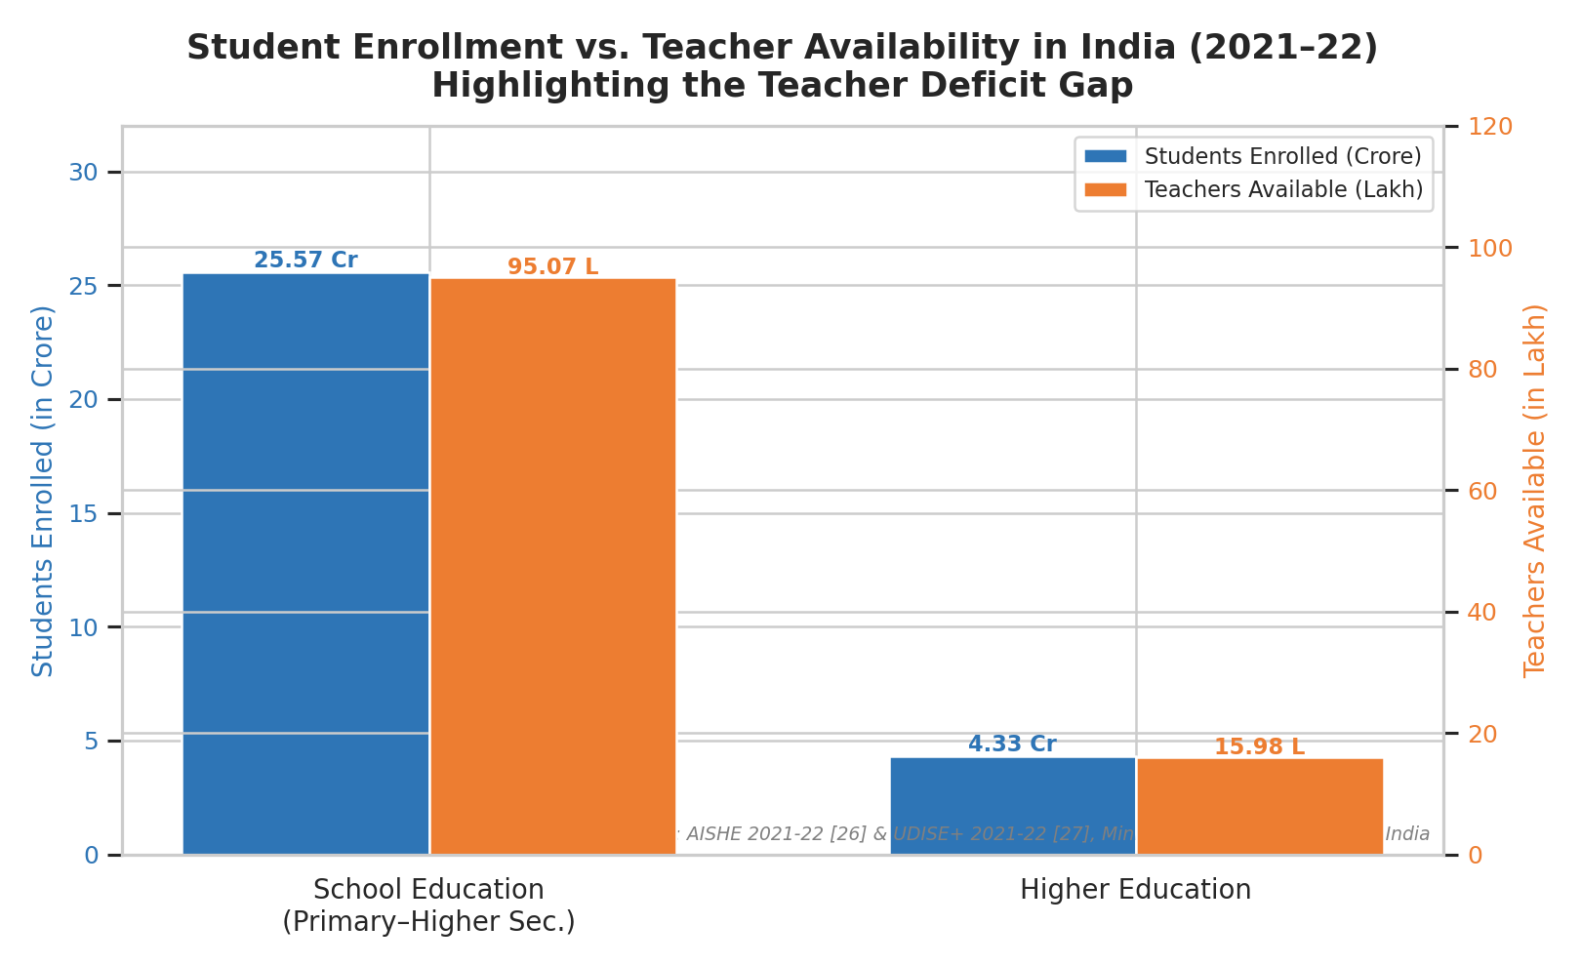
Fig. 1: Student Enrollment vs Teacher Availability in India (2021-22)

In order to create intelligent, learner-centered platforms, AI techniques have been incorporated into educational systems as a result of this gap. Recent advances in large language models (LLMs) have significantly transformed natural language understanding and generation tasks. Transformer-based architectures have demonstrated strong reasoning, summarization, and question answering performance across a variety of domains [2], [11]. However, LLMs in isolation remain susceptible to hallucination and lack of grounding in domain-specific knowledge, necessitating retrieval-augmented approaches [1], [4].

In parallel, research in intelligent tutoring systems (ITS) and multimodal learning emphasizes that learners benefit significantly from systems that combine textual, visual, and auditory modalities [6], [7], [17]. Speech-based interaction and avatar-driven instruction further increase student engagement by replicating human-like teaching environments [16], [18]. Advances in text-to-speech (TTS) [15], speech-to-text (STT) [14], and lip-sync generation have enabled the creation of expressive digital avatars capable of delivering educational content in a natural and immersive manner.

AvatarGuru.ai, a Generative AI-based avatar framework for interactive multilingual education is presented in this paper as a solution to these issues. AvatarGuru.ai enables learners to upload PDF documents and interact with the content through document-grounded question answering, AI-generated explanations, automated assessments, voice-based interaction, and lip-synchronized avatar animations. The framework leverages dense vector embeddings and semantic search [5], [21], stored in a vector database [22], to retrieve contextually relevant document segments, which are then used by an LLM to generate accurate and coherent responses [1]. The integration of speech recognition [14], speech synthesis [15], and a real-time 3D avatar rendering pipeline enables multimodal interaction, where lip movements of the avatar are dynamically synchronized with the generated speech using audio-driven facial animation.

RELATED WORK
Research related to AvatarGuru.ai spans multiple domains, including retrieval-augmented language models, intelligent tutoring systems, multimodal learning, speech-driven interfaces, and avatar-based educational environments. This section reviews key contributions in these areas and positions the proposed framework within existing literature.
2.1 Large Language Models in Education
Transformer-based large language models have demonstrated strong capabilities in language understanding, summarization, and reasoning [2], [11]. Models such as BERT [3] and LLaMA [9] have been widely adopted in downstream tasks, including educational content generation and tutoring systems. Studies have shown that LLMs can support automated feedback, question generation, and adaptive learning pathways [18].
However, LLMs operating without retrieval mechanisms often generate responses that are generic or hallucinated, especially in domain-specific educational settings [1]. This limitation motivates the integration of RAG into educational platforms, as implemented in AvatarGuru.ai.
2.2 Intelligent Tutoring Systems and AI-Based Learning Platforms
Intelligent Tutoring Systems (ITS) aim to provide personalized instruction by modeling learner knowledge and adapting content accordingly. Woolf [18] and Jain et al. [17] emphasize that effective ITS frameworks require contextual understanding, feedback generation, and learner engagement. Traditional ITS approaches, however, rely on rule-based systems or handcrafted domain models, limiting scalability and flexibility.
Recent AI-driven tutoring systems have explored conversational interfaces using chatbots and LLMs, but many lack document grounding and multimodal interaction [6]. AvatarGuru.ai addresses these limitations by integrating RAG-based reasoning with assessment generation and feedback evaluation, creating a more comprehensive learning pipeline.
2.3 Multimodal Learning and Multimedia Instruction
Multimodal learning theory suggests that combining visual, auditory, and textual modalities enhances comprehension and retention [7]. Mayer’s cognitive theory of multimedia learning highlights the importance of synchronized verbal and visual explanations to reduce cognitive load. Recent surveys confirm that multimodal AI systems improve learner engagement and accessibility [6].
Several educational platforms incorporate audio narration or video lectures; however, these systems are typically static and do not adapt dynamically to learner queries. AvatarGuru.ai extends multimodal learning by generating synchronized explanations, speech, and avatar-based videos from uploaded documents.
2.4 Retrieval-Augmented Generation and Document-Grounded QA
Retrieval-Augmented Generation (RAG) was introduced to address the limitations of purely generative language models by grounding responses in external knowledge sources. Lewis et al. [1] demonstrated that combining neural retrievers with sequence-to-sequence generators significantly improves factual accuracy in knowledge-intensive tasks. Dense Passage Retrieval (DPR) further advanced semantic document retrieval using dense vector representations [5], forming the foundation of modern RAG pipelines.
Recent surveys highlight the growing adoption of RAG in real-world applications, emphasizing its effectiveness in reducing hallucinations and improving explainability [4]. Vector similarity search systems such as FAISS [21] and Qdrant [22] have enabled scalable semantic retrieval for large document collections. These approaches directly influence the design of AvatarGuru.ai’s document ingestion and retrieval pipeline, which leverages dense embeddings for PDF-based educational content.
Despite their effectiveness, most RAG-based systems are designed for general-purpose question answering and lack educational context, assessment mechanisms, or multimodal delivery, limiting their applicability in structured learning environments.
2.5 Speech-Based Interaction and Audio-Visual Learning
Speech-based interfaces have become increasingly popular due to advancements in speech recognition and synthesis. Deep learning-based speech recognition systems [13] and large-scale models such as Whisper [14] have enabled accurate transcription in multilingual settings. Similarly, neural TTS models have achieved near-human naturalness in synthesized speech [15].
In educational contexts, voice-driven interaction improves accessibility for learners with reading difficulties or visual impairments. However, most existing systems treat speech as an auxiliary feature rather than a core interaction modality. AvatarGuru.ai integrates speech-to-text and text-to-speech as primary interfaces for both learning and assessment workflows.
2.6 Avatar-Based and Lip-Sync Educational Systems
Avatar-driven learning environments aim to simulate human tutors and enhance learner engagement. Recent research on talking-head animation and audio-driven facial motion modeling demonstrates significant progress in synchronizing facial movements with speech [16]. Such systems have been explored in virtual assistants and customer interaction but remain underutilized in education.
Existing avatar-based tutors often rely on pre-scripted content or limited conversational abilities. AvatarGuru.ai differentiates itself by dynamically rendering a 3D avatar in real time and synchronizing its lip movements with AI-generated speech, enabling responsive and interactive instructional delivery, creating a responsive and interactive educational experience.
2.7 Summary and Research Gap
While prior work has independently explored RAG, LLM-based tutoring, multimodal learning, speech interfaces, and avatar-based systems, there is a clear lack of integrated frameworks that unify these components for document-centric education. AvatarGuru.ai addresses this gap by combining retrieval-augmented intelligence, multimodal interaction, automated assessment, and avatar-driven instruction within a scalable system architecture.

SYSTEM ARCHITECTURE
The proposed AvatarGuru.ai framework is designed as a modular, component-driven system that integrates document ingestion, generative AI, multimodal interaction, semantic retrieval and assessment into a unified educational platform. The overall architecture is organized into four primary functional components — the Upload Component, the Q&A Component, the Learning Component, and the Assessment Component — all of which interact through a central MongoDB database that serves as the shared data persistence layer.

Upload Component
The Upload Component serves as the entry point of the system. The user begins by uploading a PDF document through the frontend interface. Upon upload, the system extracts the file path and parses the raw document content. The extracted data is then passed through two parallel processing pipelines: first, it is forwarded to a vectorization module that generates dense semantic embeddings, which are stored in a vector database to support retrieval-augmented query resolution; second, the raw data is passed to a Large Language Model (LLM) for summary generation, producing a structured Generated Text representation of the document. Both the vector embeddings and the generated text are persisted in MongoDB for downstream consumption by the remaining components.

Learning Component
The Learning Component is responsible for the multimodal, avatar-driven instructional experience that distinguishes AvatarGuru.ai from conventional e-learning platforms. The generated text retrieved from MongoDB is first passed through a Text-to-Speech (TTS) model, which synthesizes natural-sounding audio from the textual content [15]. The generated audio is then fed into the Avatar Model, a 3D avatar constructed in Blender, where real-time lip synchronization is performed by analyzing audio amplitude signals to dynamically animate the avatar's facial movements in correspondence with the synthesized speech [16]. The resulting lip-synchronized avatar delivers the educational content through the Learning Platform, providing an immersive, human-like tutoring experience that combines auditory and visual modalities to enhance learner engagement and comprehension [6], [7].

Q&A Component
The Q&A Component provides document-grounded conversational interaction. When a user submits a natural language query, the system performs a semantic retrieval operation against the vector database, identifying the most contextually relevant document segments. The retrieved data is then passed to an LLM, which synthesizes a coherent and contextually accurate answer grounded in the uploaded document. The generated answer is surfaced to the user through a Q&A Chatbot interface, enabling iterative, context-aware dialogue over the document content without relying solely on the parametric knowledge of the LLM.

Assessment Component
The Assessment Component closes the learning loop by evaluating the learner's understanding of the document content. The generated text stored in MongoDB is retrieved and passed to an LLM, which formulates assessment questions based on the document content. The learner is presented with these questions and submits their responses through the interface. The submitted answers are then evaluated by a second LLM invocation, which analyzes the correctness and depth of the learner's response and generates structured feedback. This automated, document-grounded assessment pipeline enables personalized, content-specific evaluation without requiring manual question authoring.

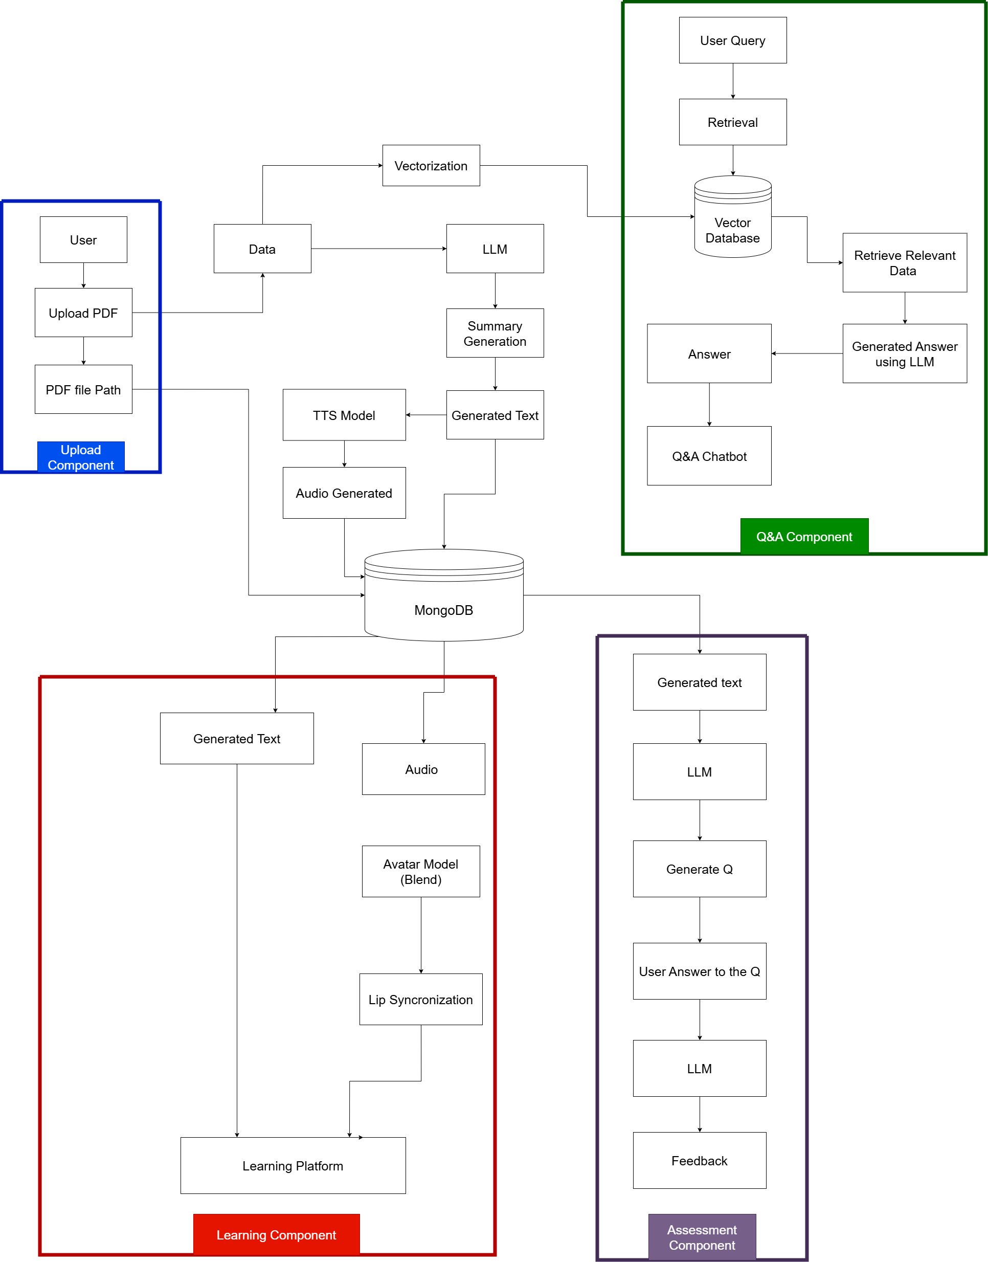

Fig 2: System Architecture

Central Data Layer — MongoDB
MongoDB serves as the central data persistence layer interconnecting all four components. It stores the LLM-generated text summaries produced during the upload phase, which are subsequently consumed by both the Learning Component for audio-visual rendering and the Assessment Component for question generation. This centralized architecture ensures consistency of content across all modalities and eliminates redundant re-processing of the source document.

METHODOLOGY
The AvatarGuru.ai framework follows a document-centric, retrieval-augmented, multimodal learning methodology that transforms unstructured educational content into an interactive and adaptive learning experience. The methodology is organized into sequential stages, beginning with document ingestion and ending with multimodal content delivery and assessment.

4.1 Document Ingestion and Preprocessing

The learning workflow begins with the upload of PDF documents by the user. Since educational documents often contain long and unstructured text, preprocessing is required to enable effective semantic retrieval.
The uploaded PDF is first parsed to extract raw textual content. The extracted text is then segmented into overlapping chunks using a fixed window size with partial overlap. This overlap preserves semantic continuity across adjacent chunks and prevents information loss at chunk boundaries. Similar chunking strategies have been shown to
improve retrieval quality in document-grounded QA systems [1], [5].
Formally, let the document 𝐷 be split into 𝑛 text segments:
𝐷 = {𝑐1,𝑐2,…,𝑐𝑛}
where each chunk 𝑐𝑖 ​represents a contiguous span of text.

4.2 Explanation Generation with Context Preservation

AvatarGuru.ai generates structured explanations from uploaded documents. To handle long documents that exceed model context limits, a sliding context window approach is employed.
Each chunk is processed sequentially, while a summary of the previous chunk is appended to the current prompt. This enables continuity across sections and improves coherence in generated explanations. Similar context-preserving strategies are commonly used in long-document summarization tasks [2], [11].
Generated explanations and reference links are stored persistently and reused across learning, assessment, and speech workflows.

4.3 Embedding Generation and Vector Storage

Each text chunk is transformed into a dense vector representation using a transformer-based embedding model. Dense embeddings capture semantic similarity beyond keyword matching and are essential for effective retrieval in RAG pipelines [5].
Several embedding models were considered for this task, including OpenAI’s text-embedding-ada-002 and sentence-transformers (all-MiniLM-L6-v2). BGE-base-en-v1.5 (BAAI General Embedding) was selected due to its strong performance on retrieval benchmarks, its open-source availability, and its ability to run locally without API cost overhead. BGE models have demonstrated competitive performance on the MTEB leaderboard, particularly for semantic search and document retrieval tasks.
Let f(·) denote the embedding function. Each chunk embedding is computed as:
eᵢ = f(cᵢ), eᵢ ∈ ℝᵈ
where d is the embedding dimensionality.

The generated embeddings are stored in a vector database, with each document maintained as an independent collection. This isolation ensures accurate retrieval and prevents cross-document contamination. For vector storage, multiple options were evaluated, including FAISS, Chroma, and Pinecone. Qdrant was selected for its native support for named collections — enabling per-document isolation — its efficient approximate nearest neighbor (ANN) search, and its ease of local deployment. Vector databases enable efficient ANN search, allowing the system to scale to large document collections [21], [22].

4.4 Retrieval-Augmented Generation (RAG) Pipeline

The core intelligence of AvatarGuru.ai is driven by a Retrieval-Augmented Generation pipeline [1], [4], implemented using the LangChain framework. LangChain was selected over alternatives such as LlamaIndex and custom pipeline implementations due to its modular abstractions for chaining retrieval and generation components, its native integration with Qdrant and BGE embeddings, and its active community support. When a learner submits a query q, the system performs the following steps:
- Query Embedding: The query is embedded using the same embedding model used during ingestion to ensure embedding space alignment.
- Semantic Retrieval: A similarity search is performed between the query embedding and stored document embeddings. The top-k most relevant chunks are retrieved:
Cᵥ = TopK(eᵥ, {e₁, …, eₙ})
- Context Construction: The retrieved chunks are concatenated to form a contextual prompt.
- Response Generation: The contextual prompt is passed to a large language model, which generates a grounded response conditioned on the retrieved document content.
This retrieval-first strategy significantly reduces hallucinations and ensures that responses remain faithful to the source document [1], [4].

4.5 Automated Assessment and Feedback Generation

To support active learning, AvatarGuru.ai incorporates an AI-driven assessment module inspired by intelligent tutoring systems [17], [18]. Based on the generated explanations, the system automatically creates conceptual questions.
When a learner submits an answer, the response is evaluated using the same large language model used for explanation generation — Llama 3.1 8B, served via the Groq inference API. Groq’s hardware-accelerated inference ensures low-latency evaluation, which is critical for maintaining an interactive assessment experience. The system generates:
- Qualitative feedback
- Correct or improved answers
- Performance indicators
This generative evaluation approach enables flexible, open-ended assessment rather than rigid rule-based grading.
.
4.6 Multimodal Interaction Pipeline
4.6.1 Speech-to-Text Processing

For voice-based interaction, learner audio input is converted into text using a neural speech recognition model. Several options were evaluated, including Google Speech-to-Text and Azure Speech Services. OpenAI Whisper was selected due to its strong multilingual transcription capability, its open-source availability, and its direct availability through the Groq inference API — enabling fast transcription without self-hosting overhead [14]. The transcribed text is then forwarded to the RAG pipeline, ensuring parity between text and voice queries.

4.6.2 Text-to-Speech Generation

AI-generated explanations and answers are converted into speech using neural text-to-speech models. Multiple TTS options were considered, including Google Text-to-Speech, Amazon Polly, and ElevenLabs. AI4Bharat’s TTS model was selected as it is specifically designed for Indian language speakers and produces natural-sounding output with Indian English accent characteristics, making it more suitable for the target learner demographic [15]. Generated audio is stored for reuse to reduce redundant computation and latency during repeated access.

4.6.3 Avatar-Based Lip-Sync

To enhance learner engagement, synthesized speech is used to drive a real-time 3D avatar created in Blender. Two primary approaches were evaluated for avatar animation: Wav2Lip, a deep learning model for lip-sync video generation, and Tavus API, a commercial service for personalized video avatars. However, both approaches require pre-rendering video output, which becomes computationally infeasible for long educational documents with dynamically generated speech.
Instead, a custom audio-driven animation approach was implemented. The audio waveform is analysed frame-by-frame to extract amplitude and energy variations, which are mapped to predefined mouth shape and jaw movement parameters in the avatar model. This audio-driven animation enables dynamic and synchronized lip movements without relying on pre-generated video, allowing the avatar to respond instantly to any generated speech.
This avatar-based delivery aligns with multimedia learning principles, which suggest that synchronized audio-visual instruction improves comprehension and retention [7].

4.7 End-to-End Learning Workflow

The complete AvatarGuru.ai methodology can be summarized as:
- PDF upload and preprocessing
2. Semantic embedding and vector storage
3. Query-based retrieval using RAG
4. Grounded explanation and answer generation
5. Multimodal delivery (text, speech, avatar video)
6. Automated assessment and feedback
This unified pipeline enables document-grounded, interactive, and personalized learning

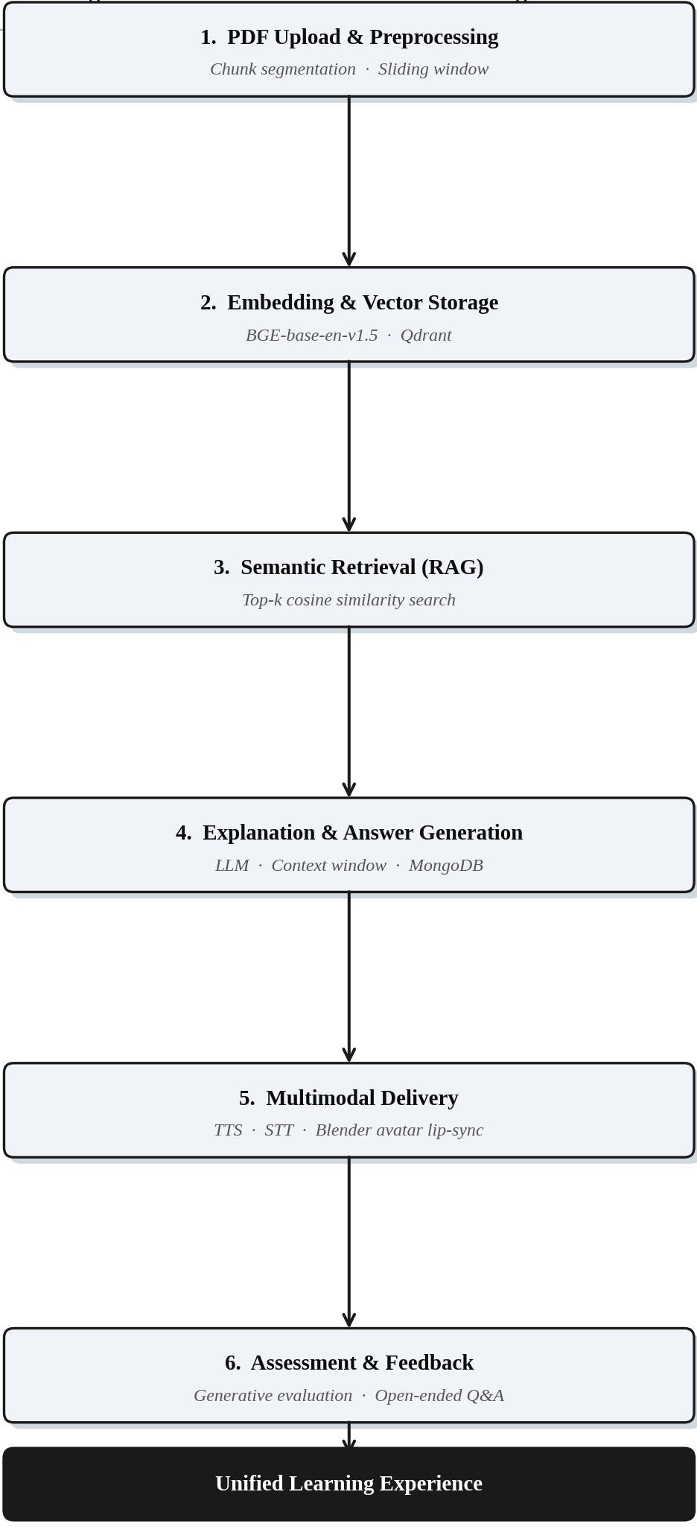
Fig 3: System Flow Diagram

IMPLEMENTATION DETAILS
The AvatarGuru.ai framework is implemented as a full-stack, modular system that integrates multimodal interaction, avatar-based content delivery through a REST-driven architecture and retrieval-augmented language modeling. The backend is developed using Python and a lightweight web framework, which exposes API endpoints for document ingestion, speech processing, assessment generation, and lip-sync with synthesis audio, semantic retrieval, question answering. The frontend is implemented as a single-page web application that communicates with backend services asynchronously, enabling real-time interaction and dynamic content updates.
To support long-document understanding, explanation generation is performed using a sliding context window strategy. The system processes document chunks sequentially while retaining summaries of previous segments in the prompt context. Using a document database, generated explanations and reference links can be reused across study, assessment, and speech synthesis modules without requiring additional computation. The system's efficiency and response latency are enhanced by this design decision. Speech-based interaction is implemented through the integration of a neural speech recognition model capable of multilingual transcription. Audio input from the user is converted into text, normalized, and forwarded to the same retrieval-augmented question answering pipeline used for text-based queries, ensuring uniform processing regardless of input modality [14]. For content delivery, a neural text-to-speech model is used to synthesize natural-sounding audio from generated explanations and answers [15].
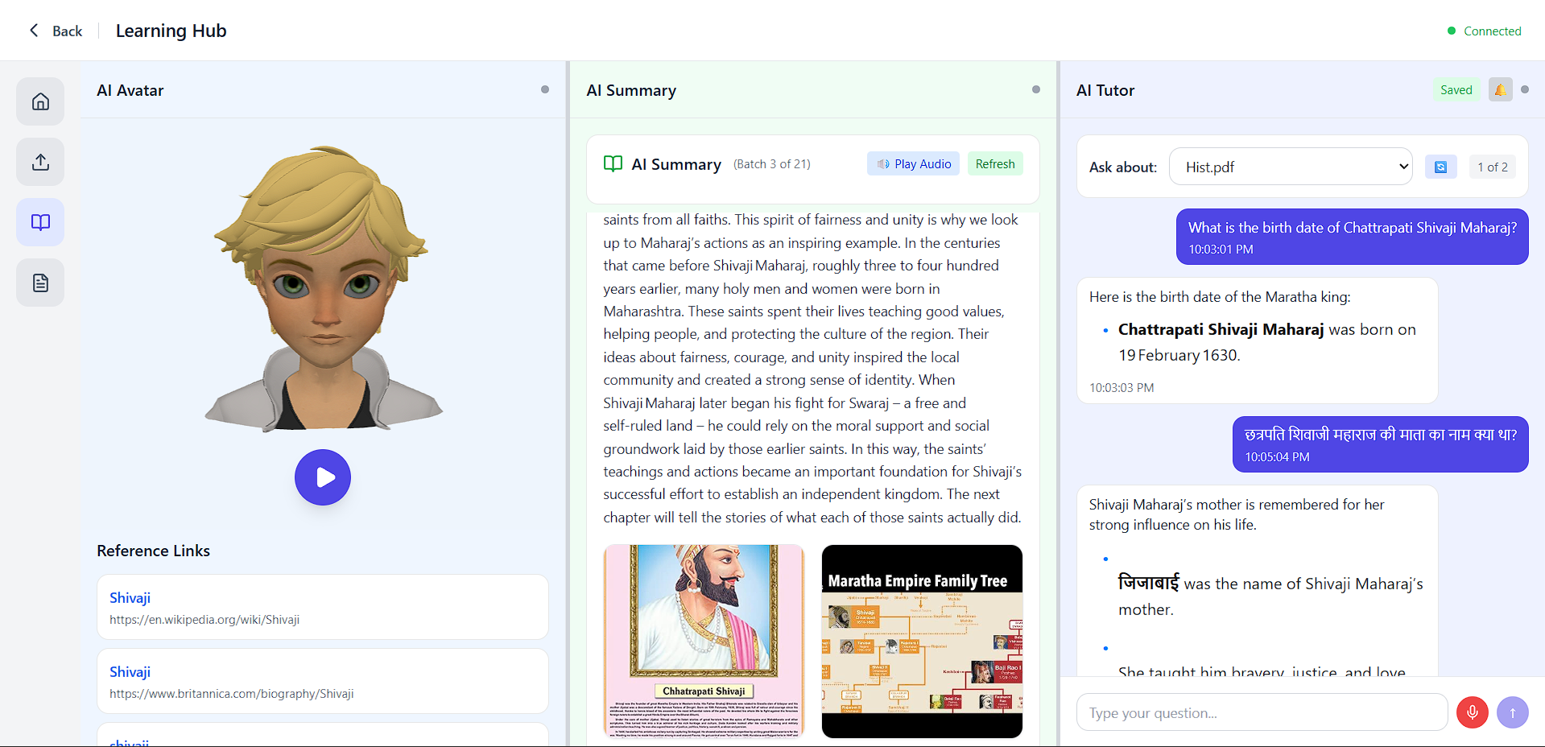
After text-to-speech synthesis, the audio signal is streamed to a locally rendered 3D avatar created in Blender. A real-time animation module analyses the audio amplitude and maps it to facial rig parameters, driving mouth opening, closing, and viseme-like movements in synchronization with the speech. This eliminates the need for external video generation services while enabling low-latency, interactive avatar animation The assessment module is implemented using the same generative language model employed for explanation and question answering. Assessment questions are generated dynamically from document explanations, and learner responses are evaluated using generative comparison rather than rule-based matching.
Document ingestion is initiated upon PDF upload, where textual content is extracted using a PDF parsing library. The extracted text is segmented into overlapping chunks to preserve contextual continuity across sections. Each chunk is transformed into a dense semantic vector using a transformer-based embedding model trained for sentence-level representation learning, consistent with dense retrieval approaches described in prior work [5]. The resulting embeddings are stored in a vector database, with each document assigned a separate collection to ensure isolation and accurate retrieval. Approximate nearest neighbour search is used during query time to efficiently identify the most relevant document segments [21], [22].
The retrieval-augmented generation pipeline is implemented using a language model orchestration framework that connects the vector retriever with a large language model. For each user query, the system embeds the query, retrieves the top-ranked document chunks, and constructs a contextual prompt that is passed to the generative model. This makes sure that the answers and explanations that are generated are based on the content of the uploaded document, which effectively reduces hallucinations and increases factual consistency [1, 4]. The same mechanism is reused for explanation generation and assessment-related reasoning, enabling code reuse and consistency across learning workflows.
To ensure robustness and scalability, the system incorporates API key rotation, asynchronous background processing, and modular service separation. Media assets such as audio and video files are managed through cloud-based storage, enabling efficient streaming and external service interoperability. Overall, the implementation of AvatarGuru.ai reflects a tightly integrated yet extensible architecture that operationalizes retrieval-augmented generation and multimodal AI for interactive educational applications.

Fig 4: Application Interface

RESULTS AND DISCUSSION

The AvatarGuru.ai framework was evaluated through end-to-end system deployment and qualitative analysis across multiple educational PDF documents. The results demonstrate that integrating Retrieval-Augmented Generation with multimodal interaction significantly improves the accuracy, relevance, and usability of AI-driven educational systems. By grounding large language model outputs in document-specific content, AvatarGuru.ai consistently generated responses that were contextually aligned with the source material, effectively reducing hallucinations commonly observed in standalone generative models [1], [4]. User queries related to definitions, explanations, and conceptual understanding were answered with higher factual consistency compared to text-only LLM-based systems.

The multimodal learning capabilities of AvatarGuru.ai had a noticeable impact on user engagement and accessibility. Text-to-speech generation allowed learners to consume content in an auditory format, benefiting users with reading fatigue or visual limitations. Natural voice-based interaction was made possible by the integration of speech-to-text, which also made it easier to formulate questions and made it possible to use multiple languages. Most notably, the real-time 3D avatar with audio-driven lip synchronization made tutoring more human-like, which made students more engaged. According to multimedia learning theory [7], synchronized visual and auditory instruction enhances comprehension and retention. This observation is consistent with this theory. The automated assessment module demonstrated the system’s ability to support formative learning. Generated questions were closely aligned with document content, and the evaluation mechanism provided meaningful feedback rather than binary correctness judgments.

The semantic retrieval mechanism played a crucial role in maintaining response quality. Dense vector embeddings enabled the system to retrieve relevant document segments even when learner queries were paraphrased or loosely structured, confirming the effectiveness of semantic similarity search over traditional keyword-based retrieval [5], [21]. Isolating embeddings per document further improved precision by preventing cross-document interference, which is particularly important in educational settings where conceptual overlap between subjects can lead to ambiguity

From a system performance perspective, the modular architecture enabled efficient handling of concurrent tasks such as document ingestion, retrieval, and multimedia generation. Background processing and content persistence cut down on unnecessary computation, speeding up responses to multiple interactions. The use of vector databases and cloud-based media storage ensured scalability and robustness, suggesting that the framework can be extended to support larger document collections and user bases.

Despite these positive outcomes, certain limitations were observed. The underlying language model continues to influence the quality of generated explanations and assessments, and highly technical or mathematical documents occasionally necessitated a more precise retrieval context. Additionally, avatar video generation from Tavus API or Wav2Lip introduced higher latency compared to text or audio responses due to external processing constraints. These limitations highlight areas for future optimization, such as adaptive retrieval strategies and lightweight avatar models.

Overall, the results indicate that AvatarGuru.ai successfully bridges the gap between static digital learning resources and interactive AI-driven education. By unifying retrieval-augmented intelligence, multimodal interaction, and avatar-based instruction, the framework demonstrates strong potential for deployment in real-world educational environments, particularly in self-paced and remote learning scenarios

CONCLUSION

AvatarGuru.ai, a Generative AI-based educational framework that enables interactive learning by combining multimodal and avatar-driven interaction with Retrieval-Augmented Generation, was presented in this paper. By combining large language models, speech-based interfaces, semantic retrieval, and a real-time 3D avatar with audio-driven lip synchronization, the proposed system transforms static educational documents into an engaging and adaptive learning experience. The framework addresses key limitations of conventional AI tutors by ensuring factual grounding, supporting multimodal accessibility, and enabling automated assessment with meaningful feedback.

The experimental deployment and qualitative evaluation demonstrate that AvatarGuru.ai effectively improves contextual accuracy, learner engagement, and content accessibility compared to text-only learning systems. The framework is scalable and extensible because of its modular architecture, which enables the seamless integration of document ingestion, retrieval, generation, and multimedia delivery. While certain challenges remain, such as latency in avatar video generation and dependency on underlying language models for highly technical content, the results indicate strong potential for real-world educational deployment.

India's education system faces a structural teacher deficit that no conventional policy intervention has been able to fully resolve at scale. With a national Pupil Teacher Ratio of 24 at the higher education level and over 56,000 single-teacher schools concentrated predominantly in rural areas, millions of learners across the country receive instruction that is constrained by geography, resource scarcity, and linguistic diversity [26], [27]. AvatarGuru.ai directly addresses these structural gaps. By enabling any learner with access to a device and an internet connection to upload a curriculum document and receive personalized, voice-interactive, avatar-delivered instruction in their preferred language, the framework functions as a scalable virtual teacher capable of operating where qualified human instructors are unavailable. For rural K–12 students attending single-teacher schools in states such as Bihar, Uttar Pradesh, and Rajasthan — where PTRs reach as high as 74 at the university level — AvatarGuru.ai offers a means of supplementing overburdened instructors with always-available, document-grounded AI tutoring [26]. At the higher education level, the framework supports self-paced university revision, reducing dependency on limited faculty contact hours. The integration of Indian-language optimized speech recognition and synthesis models ensures that the platform is accessible to learners across all 22 scheduled languages of India, directly addressing the linguistic exclusion that has historically limited the reach of digital education tools. Furthermore, the automated assessment module enables continuous formative evaluation without requiring teacher presence, supporting the kind of active, reflective learning that improves long-term retention and academic outcomes [17], [18]. In alignment with the National Education Policy 2020's vision of technology-enabled, inclusive, and multilingual education [28], AvatarGuru.ai represents a concrete and deployable step toward democratizing quality education across India's diverse and underserved learner population.

Overall, AvatarGuru.ai highlights the feasibility and benefits of combining retrieval-augmented intelligence with generative avatars for next-generation intelligent tutoring systems. Future AI-driven educational platforms that aim to deliver personalized, interactive, and inclusive learning experiences on a large scale will be built on the proposed framework.

REFERENCES

- P. Lewis et al., “Retrieval-Augmented Generation for Knowledge-Intensive NLP Tasks,” Advances in Neural Information Processing Systems (NeurIPS), vol. 33, pp. 9459–9474, 2020.
- T. Brown et al., “Language Models are Few-Shot Learners,” Advances in Neural Information Processing Systems (NeurIPS), vol. 33, 2020.
- J. Devlin et al., “BERT: Pre-training of Deep Bidirectional Transformers for Language Understanding,” Proceedings of NAACL-HLT, pp. 4171–4186, 2019.
- Y. Gao et al., “Retrieval-Augmented Large Language Models: A Survey,” arXiv preprint arXiv:2312.10997, 2023.
- S. Karpukhin et al., “Dense Passage Retrieval for Open-Domain Question Answering,” Proceedings of EMNLP, pp. 6769–6781, 2020.
- J. Glass et al., “Multimodal Learning for Education: A Review,” IEEE Transactions on Learning Technologies, vol. 15, no. 2, pp. 123–138, 2022.
- R. Mayer, Multimedia Learning, 2nd ed., Cambridge University Press, 2009.
- M. Chen et al., “Evaluating Large Language Models Trained on Code,” arXiv preprint arXiv:2107.03374, 2021.
- H. Touvron et al., “LLaMA: Open and Efficient Foundation Language Models,” arXiv preprint arXiv:2302.13971, 2023.
- A. Radford et al., “Learning Transferable Visual Models From Natural Language Supervision,” Proceedings of ICML, 2021.
- A. Vaswani et al., “Attention Is All You Need,” Advances in Neural Information Processing Systems (NeurIPS), 2017.
- D. Bahdanau, K. Cho, and Y. Bengio, “Neural Machine Translation by Jointly Learning to Align and Translate,” Proceedings of ICLR, 2015.
- A. Graves et al., “Speech Recognition with Deep Recurrent Neural Networks,” IEEE International Conference on Acoustics, Speech and Signal Processing (ICASSP), 2013.
- A. Radford et al., “Robust Speech Recognition via Large-Scale Weak Supervision,” arXiv preprint arXiv:2212.04356, 2022.
- J. Shen et al., “Natural TTS Synthesis by Conditioning WaveNet on Mel Spectrogram Predictions,” ICASSP, 2018.
- S. Ren et al., “Deep Learning-Based Talking Head Generation: A Survey,” IEEE Transactions on Pattern Analysis and Machine Intelligence, 2023.
- A. K. Jain et al., “Human–Computer Interaction in Intelligent Tutoring Systems,” IEEE Computer, vol. 52, no. 6, pp. 45–56, 2019.
- M. Woolf, Building Intelligent Interactive Tutors, Morgan Kaufmann, 2010.
- Y. LeCun, Y. Bengio, and G. Hinton, “Deep Learning,” Nature, vol. 521, pp. 436–444, 2015.
- M. Zaharia et al., “Accelerating the Machine Learning Lifecycle with MLflow,” IEEE Data Engineering Bulletin, vol. 41, no. 4, 2018.
- J. Johnson, M. Douze, and H. Jégou, “Billion-Scale Similarity Search with GPUs,” IEEE Transactions on Big Data, 2019.
- Qdrant Team, “Qdrant: Vector Search Engine for AI Applications,” Technical White Paper, 2023.
- H. LangChain Contributors, “LangChain: A Framework for Developing Applications Powered by Language Models,” Open-source documentation, 2023.
- AWS, “Amazon Simple Storage Service (S3): Developer Guide,” Amazon Web Services, 2023.
- A. Abowd et al., “Towards a Better Understanding of Context and Context-Awareness,” Proceedings of HUC, Springer, 1999.
- Ministry of Education, Government of India, "All India Survey on Higher Education (AISHE) 2021–22," Ministry of Education, New Delhi, 2022.
- Ministry of Education, Government of India, "Unified District Information System for Education Plus (UDISE+) 2021-22," Department of School Education & Literacy, New Delhi, 2022.
- Ministry of Education, Government of India, "National Education Policy 2020," Ministry of Education, New Delhi, 2020.

